Dialects and Dialectology

- Dialect, Accent, and Language
  - Ways of talking that are more or less distinctive for groups of people
  - Accent usually refers to pronunciation features
  - Dialect includes pronunciation, as well as grammatical and lexical distinctions
  - Both terms refer to distinctive ways of talking, but no clear-cut definition for them
- Language and Dialect
  - “Language” is not purely a linguistic notion
  - There are sociocultural and political factors
  - What about Norwegians and Swedes?
  - Standardization: we see ourselves as speaking a dialect of the standard language
- Standards and Dialects
  - Regional standards for spoken language
  - Defined negatively (“The regional standard is not x, y, or z…”)
  - Regional standards: they’re still dialects!
- Regional Dialects, Sociolects, and Ideolects
  - Sociolect: A social dialect, language variety we speak that reflects where we’re at in social space
  - Has to do with social groups: One city or region can have many sociolects
  - Often has to do with ethnicity and class differentiation
  - Ideolect: Our own unique variety
    - We all have a somewhat different set of conventions in our heads
    - Why? Different memories, different grammars
  - Bottom Line: Everyone has an accent!
- Dialects: Some Concepts to Think With
  - Continua: Both Social and Geographic
  - Social Dialect Continua: As you move through social space, language changes incrementally, bit-by-bit
  - Usually refers to a gradient social dimension, like class
  - Example: Jamaican Creole

It’s my book I didn’t get any Do you want to cut it?
its mai buk ai didnt get eni du ju want tu kΛt it
iz mai buk ai didn get non du ju wa:n tu kot it
iz mi buk a din get non ju wa:n kot it
a mi buk dat a in get non iz kot ju wa:n kot it
a fi mi buk dat mi na bin get non a kot ju wa:n fu kot it

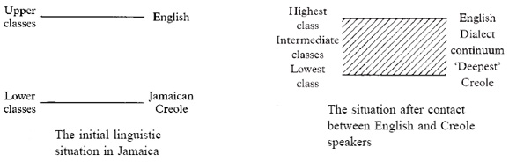

  - Geographical Dialect Continua: Similar to social dialect continua
  - In some parts of the world, if we start at one point in a rural area and travel to another part, we’ll notice differences in speech
  - Cumulative differences as we move from point A to point B
  - Farther we go along this path, the greater the differences compared to where we started
  - Some examples: West Romance and West Germanic dialect continua
  - Boundaries: The idea of an isogloss
  - Isoglosses indicate geographic boundaries between the use and non-use of a linguistic feature (couch vs. sofa, for example, or a pronunciation feature)
  - Example: Pail vs Bucket in southern and northern parts of Pennsylvania
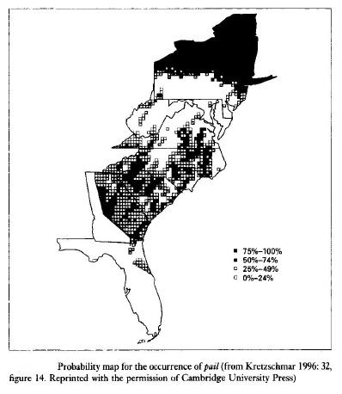
  - In many cases, we don’t see discrete isoglosses
  - Rather, we see continua, with variants coexisting in areas called transition zones
- Dialectology: methods
  - Really, really long survey
  - Asked “frame” questions to get respondents to use a certain word
  - Usually looked at lexical variation
  - The interviewees were NORMS: non-mobile, older, rural males
  - Why did dialectologists look at these people?
  - What are some of the problems with this methodology?

